Truro Cycle Club - OPEN 10 Mile Time Trial S6/10
Part of the Cornish Cup Series
Date: 23rd July 2023
First Rider: 08:01am

This event is being held for and on behalf of Cycling Time Trials under its Rules and Regulations

Event HQ: Tresillian Village Hall, Fairfax Road, Tresillian, Cornwall TR2 4AZ
HQ open from 7am

Organising Secretary - James Manthorp
Time Keepers - Chris Fearnley, Ian Matthews
Marshalls - Paul Charlesworth, James Manthorp, TBC
Sign on assistants: Talitha and Simon
Photography by David Rickett

Course Details: This event is held on the S6/10 course – Start on B3275 (formerly the A390) at entrance to Trecurno, approximately 100 yards West of layby and 0.5 mile East of Tresillian (GR SW879470). Proceed Northeastwards for approximately 0.5 mile where turn left, still on B3275. Continue northeastwards on B3275 through Ladock and Newmills to turn at Brighton Roundabout. Retrace outward route through Newmills and Ladock. Finish at a point 5 yards before a field gate and 0.25 mile North of, and prior to, the B3275/Probus to Tresillian Road junction. (GR SW 887476) Intermediate distance: - Brighton Cross 5.4 miles

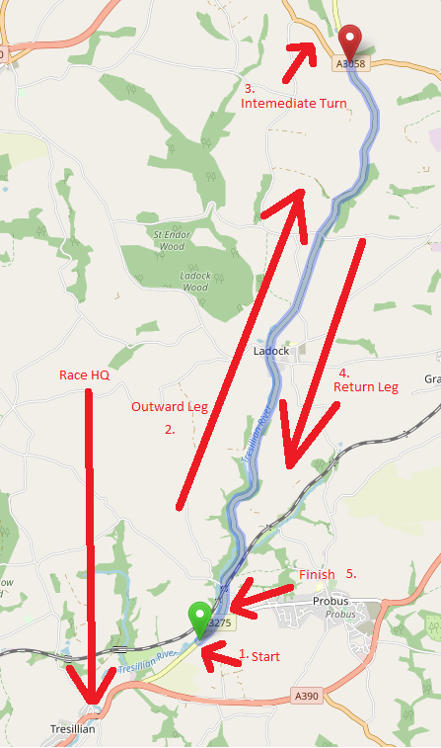

Sign On - Please Sign on at the hall from 7am. If you are a junior please bring a signed parental consent form. Please be respectful of local residents when parking and keep noise to a minimum as it is early for some.

Warming-up - Please allow ten minutes to ride to the start which is approximately 1.5 miles away. Please do not arrive more than five minutes before your start time. There is a large lay-by approximately 100 meters up the road you can wait in if early.

The course must not be used for warming up once the first rider has set off.

Front and rear lights are a requirement.
Helmets must be worn.
Sleeveless Jerseys or Tri-suits are not permitted.

Road Bike Category additional regulations - No tri-bars, club on bars, spinacci bars are allowed. No disc wheels, both front and rear wheels must have at least 12 spokes each. The maximum rim depth allowed is 90mm.

During the race - please respect the marshalls if you are told to stop. Please note that Marshalls are not there to stop traffic or give directions. Please shout your number at the finish.

After the race - please return to the hall and sign back in, do not warm down on the course.

Our club secretary, George, would like to invite everyone to join and watch the tour de france at the old ale house in the afternoon.

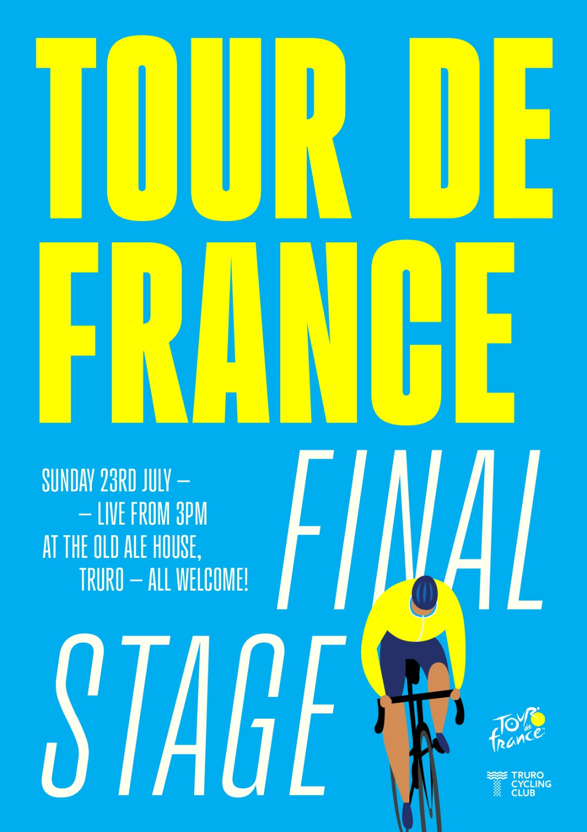

S6/10 Course Records as of 16.07.23

Solo Male
00:19:46
Steve Lampier
09-May-21 | Tri-logic (inc SW DC Champs)
Solo Female
00:22:45
Melanie Sneddon
05-Aug-18 | giant helston
Solo Male (Junior)
00:21:23
Harry Jukes
09-May-21 | Tri-logic (inc SW DC Champs)
Solo Female (Junior)
00:25:38
Hannah Rainger
30-Aug-20 | Saint Piran
Team TT
00:23:53
Tom Smith, Nigel Polkinghorne
03-Apr-22 | Penzance Wheelers CC (2-up TTT)(fee per rider)

Startsheet

Number | Time | Name | Club | Category
1 | 8:01:00 | Anthony Green | Penzance Wheelers CC
2 | 8:02:00 | William Kinnear | Truro CC
3 | 8:03:00 | Aaron Jones | Truro CC
4 | 8:04:00 | Melinda Rickett | Truro CC | W
5 | 8:05:00 | Lucy Rickett | Truro CC | W
6 | 8:06:00 | Holly Tregear | Wheal Velocity | W
7 | 8:07:00 | Gary Hickman | Tri Logic Cornwall
8 | 8:08:00 | Finian O'Donnell | Truco CC
9 | 8:09:00 | Ian Darcy | Saint Piran
10 | 8:10:00 | Allister Young | Truro CC
11 | 8:11:00 | Lee Chance | Truro CC
12 | 8:12:00 | John Trott | Saint Piran
13 | 8:13:00 | Owain Barrett | Tri Logic Cornwall
14 | 8:14:00 | Sophie Butcher | Tri Logic Cornwall | W
15 | 8:15:00 | Robin Brown | St Austell Wheelers CC
16 | 8:16:00 | Neil Bennett | North Devon Velo
17 | 8:17:00 | Peter Blackshaw | Penzance Wheelers CC
18 | 8:18:00 | Mark King | Tri Logic Cornwall
19 | 8:19:00 | Damian Cudmore | Wadebridge Coasters Cycling Club
20 | 8:20:00 | Huw Greenish | Truro CC
21 | 8:21:00 | John Fazakerly | Penzance Wheelers CC
22 | 8:22:00 | Rose Willis | St Austell Wheelers CC | W
23 | 8:23:00 | Martina Geraghty | Penzance Wheelers CC | W
24 | 8:24:00 | Peter Miners | Duchy Velo
25 | 8:25:00 | Andrew Ellis | www.giant-helston.co.uk
26 | 8:26:00 | Graham Lobb | www.giant-helston.co.uk
27 | 8:27:00 | Nathan Jenkin | Tri Logic Cornwall
28 | 8:28:00 | Craig Morris | Royal Navy & Royal Marines CA
29 | 8:29:00 | Larry Martin | Tri Logic Cornwall
30 | 8:30:00 | Aditya Sekharipuram Viswanath | Keele University CC
31 | 8:31:00 | Michael Hooper | .05/03
32 | 8:32:00 | John Morse | Penzance Wheelers
33 | 8:33:00 | Ian Houvenaghel | Saint Piran
34 | 8:34:00 | Sam Beaton | Plymouth Corinthian CC
35 | 8:35:00 | Craig Harper | Holsworthy Peloton
36 | 8:36:00 | Oliver Baylin | www.giant-helston.co.uk
37 | 8:37:00 | James Grogan | www.giant-helston.co.uk
38 | 8:38:00 | Felix Whetter | Mid Devon CC
39 | 8:39:00 | Nigel Polkinghorne | Duchy Velo

